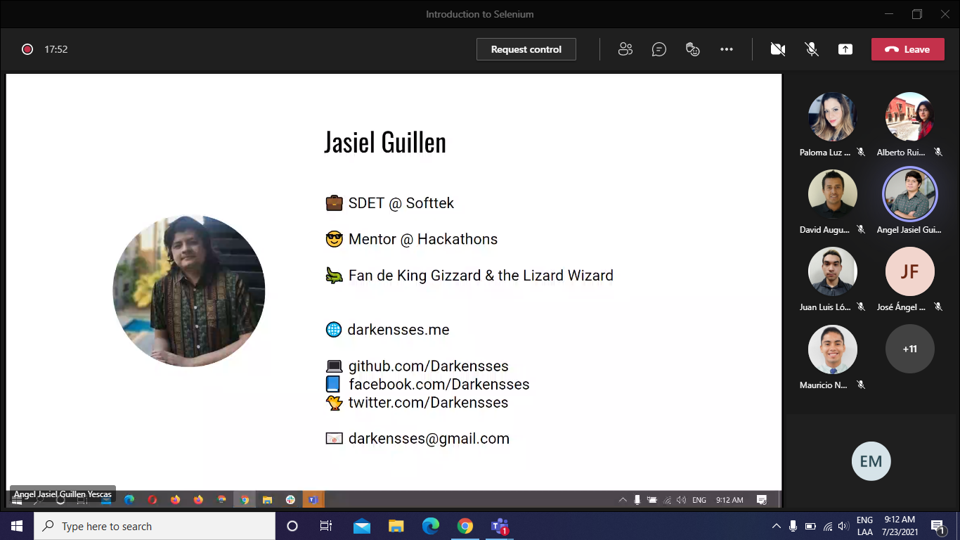

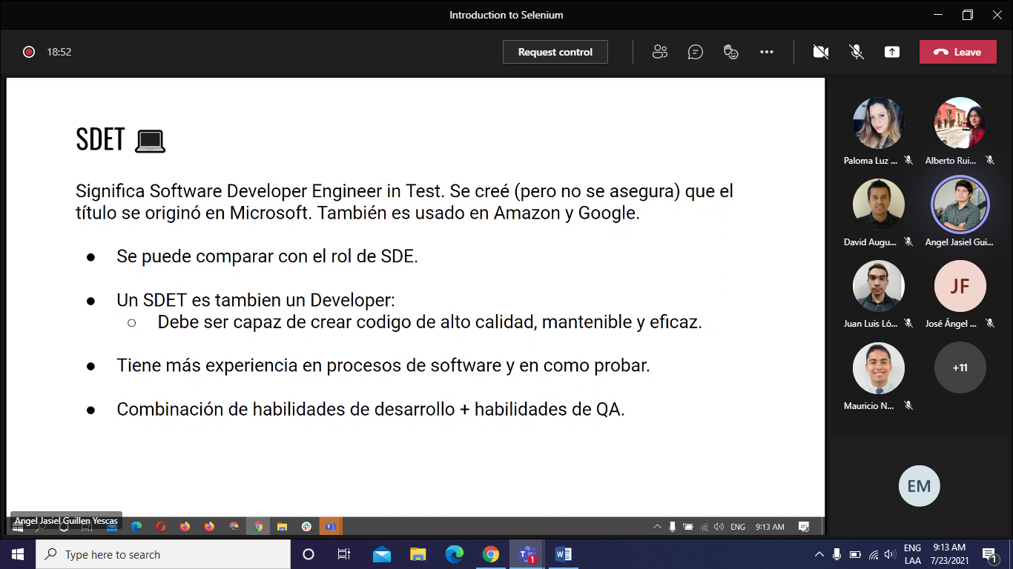

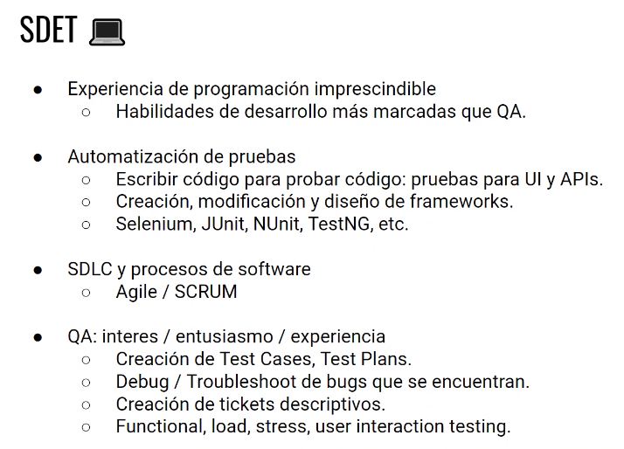

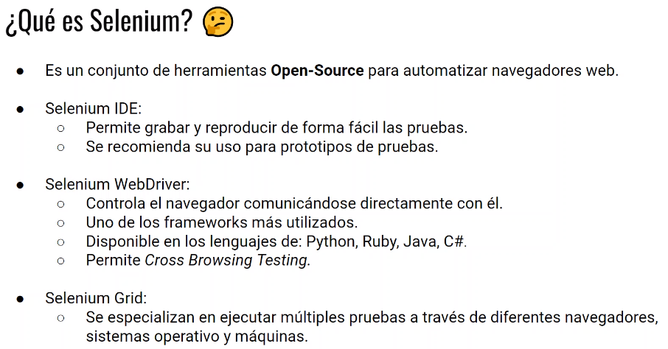

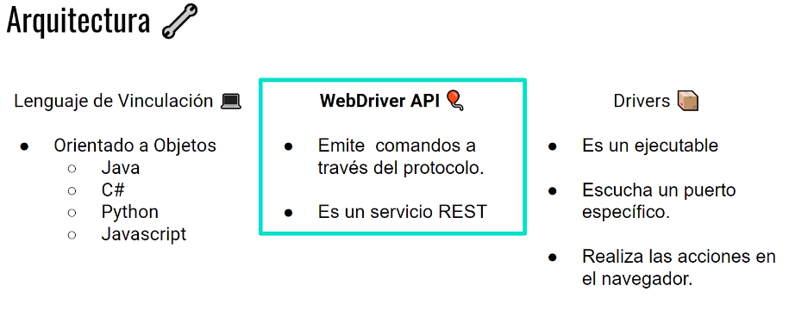

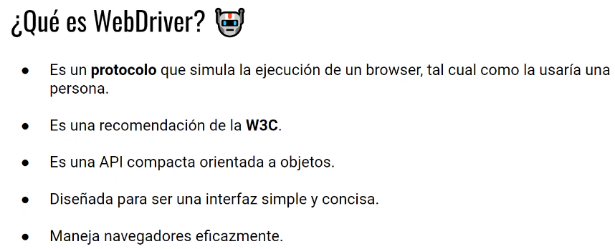

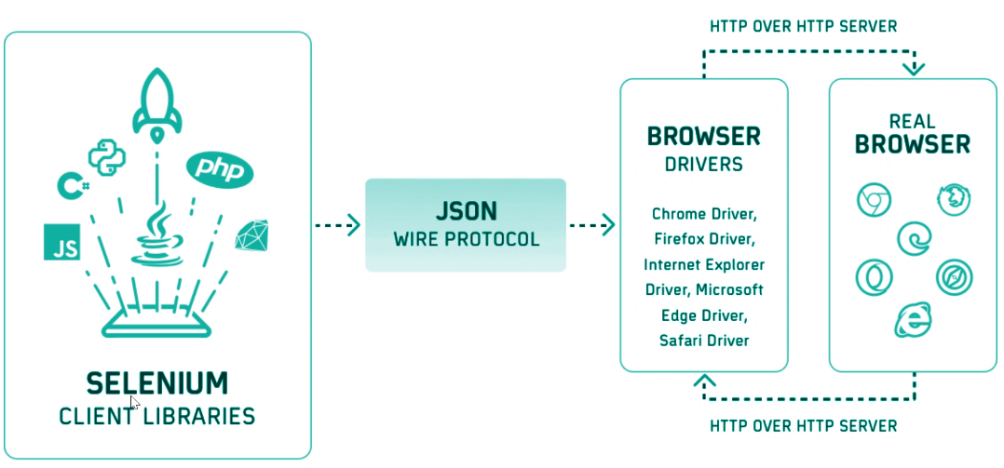

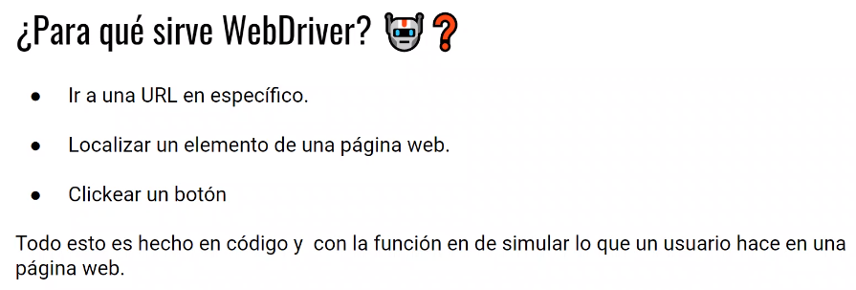

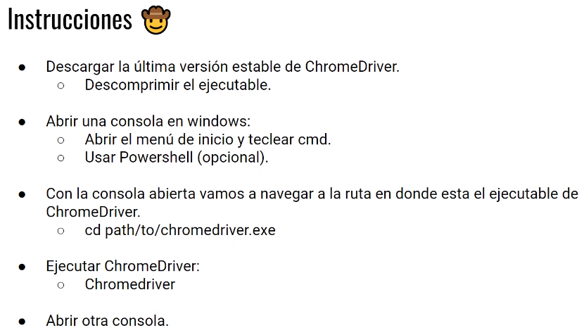

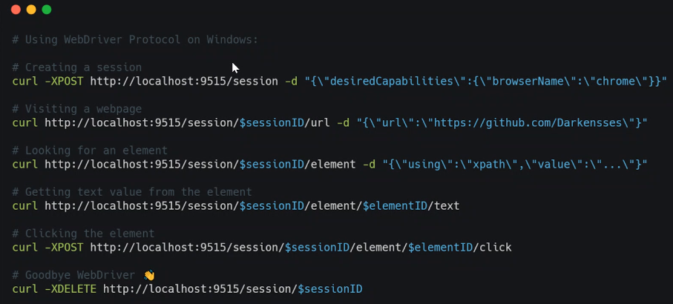

curl -XPOST http://localhost:9515/session -d "{\"desiredCapabilities\":{\"browserName\":\"chrome\"}}"

curl http://localhost:9515/session/3a046b8b15d46ee5ebd706048075a24e/url -d "{\"url\":\"https://github.com/Darkensses\"}"

sessionID: 3a046b8b15d46ee5ebd706048075a24e

elementID: 0.3109615749890364-1

curl http://localhost:9515/session/3a046b8b15d46ee5ebd706048075a24e/element -d "{\"using\":\"xpath\",\"value\":\"//span[@title='react-leap-visualizer']\"}"

curl http://localhost:9515/session/3a046b8b15d46ee5ebd706048075a24e/element/0.3109615749890364-1/text

curl –XPOST http://localhost:9515/session/3a046b8b15d46ee5ebd706048075a24e/element/0.3109615749890364-1/click

curl -XDELETE http://localhost:9515/3a046b8b15d46ee5ebd706048075a24e/

